LVDB Interactive Fault Simulation Software (DEWA Standard Based)

1️⃣ System Overview
The system shall simulate an LV Distribution Board (LVDB) including:
- 1 × Main 4P Isolator
- 5 × ELCBs in parallel
  - ELCB1 – 40A, 100mA feeds to (6 MCBs)
  - ELCB2 – 40A, 100 mA feeds to (3 MCBs)
  - ELCB3 – 40A, 30mA feeds to (3 MCBs)
  - ELCB4 – 40A, 100mA feeds to (UVR + Timer Contactor + 3 MCBs)
  - ELCB5 – 40A, 1000mA feeds to (UVR + Timer Contactor + 3 MCBs)

The simulator should be fully interactive and touchscreen operated.

2️⃣ Program Operation Sequence (Core Logic)
🔹 Step 1 – Fault Selection Screen
When the program starts:
Display message:
“Kindly Select the Faulty Circuit”
User must select:
- Anyone MCB from:
  - ELCB1 (MCB1–MCB6)
  - ELCB2 (MCB7–MCB9)
  - ELCB3 (MCB10–MCB12)
  - ELCB4 +UVR+TIMER (MCB13–MCB15)
  - ELCB5+UVR+TIMER (MCB16–MCB18)
OR
Randomized blind test (faulty MCCB to be select by system Multiple circuits but from different ELCBs).
OR
If there is no faulty circuit simulated all MCB & ELCB work fine(to be in on position).
Once selected → System loads digital LVDB screen.
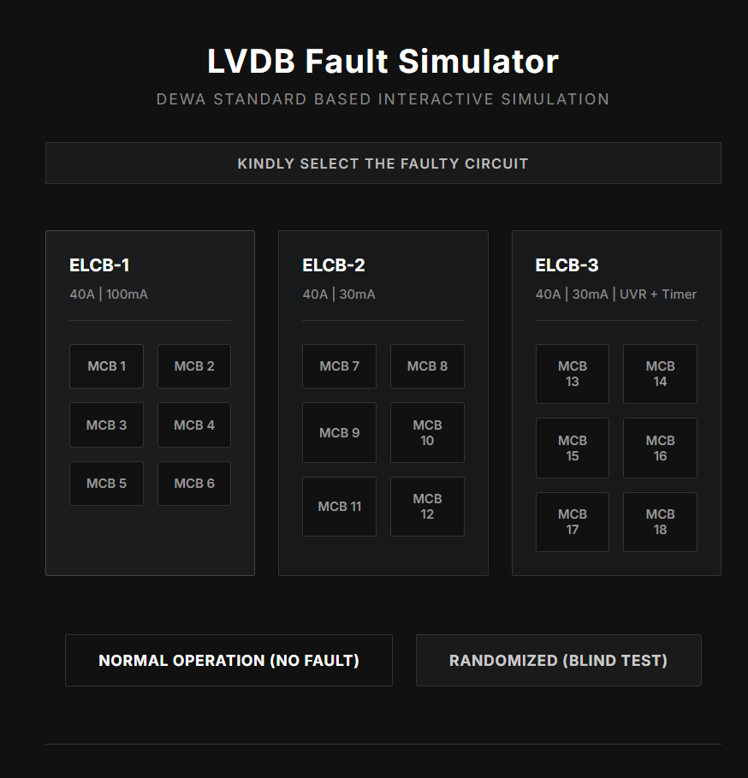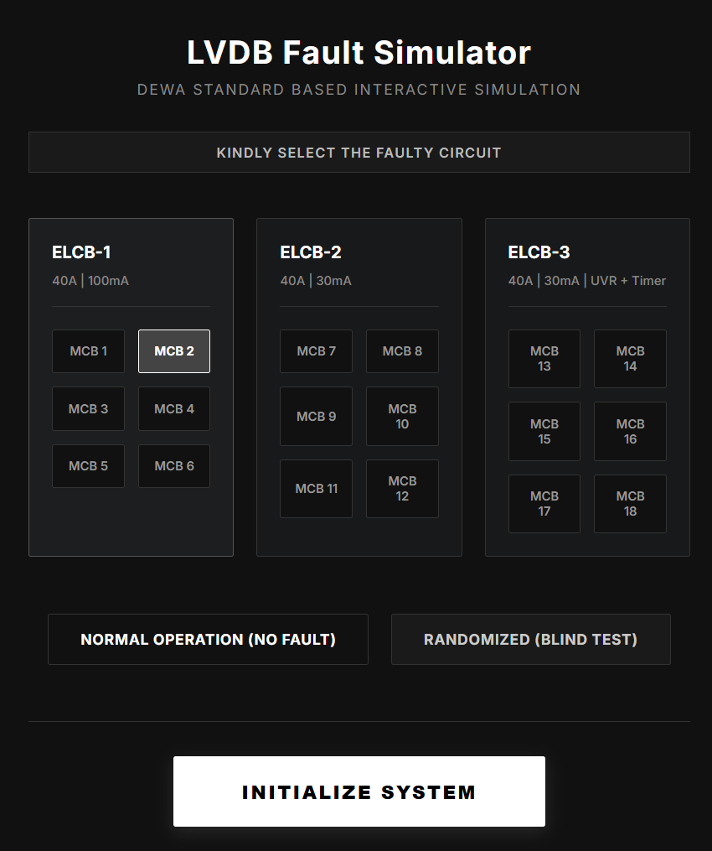
Screen Before selecting faulty cicuit Screen after selecting faulty cicuit

🔹 Step 2 – Main Isolator Operation
- User touches Main Isolator knob.
- Knob animation moves to UP position.
- Indicator lamp turns GREEN.
- System becomes energized.
If isolator is OFF → No other device can be switched ON.

🔹 Step 3 – ELCB Operation
For ELCB-1 to ELCB-3.
User switches ON ELCBs one by one:
- Knob moves UP.
- Indicator changes to GREEN.
- Downstream MCBs become enabled.
If ELCB not ON → Related MCBs cannot be switched ON.
For ELCB-4 to ELCB-5.
User switches ON ELCBs one by one:
- Knob moves UP.
- Indicator changes to GREEN.
- UVR timer starts after ELCB switching ON with 2 indications one red & one orange. After 10 seconds. Orange indication becomes Green & contractor energized ,
- Indicator changes to GREEN for contractor
- Downstream MCBs become enabled.
If ELCB not ON → Related UVR Timer+ contractor cannot be switched ON.

🔹 Step 4 – MCB Operation (Sequential Switching)
User switches ON MCBs one by one.
For MCB from MCB-1 to MCB-12:
- Knob moves UP.
- Indicator turns GREEN.
- Load indicator becomes active.
For MCB from MCB-13 to MCB-18:
- Knob moves UP .
- Indicator turns GREEN.
- Load indicator becomes active

3️⃣ Fault Trigger Logic (Very Important)
When the user reaches the pre-selected faulty MCB:
System must:
1️⃣ Trip its respective ELCB
2️⃣ Change ELCB indicators to RED
3️⃣ Knobs move to DOWN position
4️⃣ Display message:
“Earth Leakage Fault Detected on [MCB Name]”
Example:
If fault selected = ELCB2 → MCB2
Then:
- MCB2 trips
- ELCB2 trips
- Other ELCBs remain ON

4️⃣ Protection Behavior Logic
Fault Location | Result
Fault under ELCB1 | Only ELCB1 trips
Fault under ELCB2 | Only ELCB2 trips
Fault under ELCB3 | Only ELCB3 trips
Main isolator OFF | Entire DB de-energized
Selective tripping must be implemented.

5️⃣ Visual & Interface Requirements
The LVDB screen must include:
✅ Single Line Diagram layout
✅ Realistic toggle knob animation
✅ Color Indicators:
- Green = ON
- Red = Trip
- Grey = OFF
✅ Event message window
✅ Reset button
✅ Back to fault selection screen
✅ Alarm sound (optional)

6️⃣ Reset Logic
After fault trip:
User must:
- Switch OFF all MCB of respective ELCB.
- Switch OFF tripped ELCB(Already in tripped position).
- Press RESET button
- Then restart procedure
System should not auto-reset.

7️⃣ Optional Advanced Features (Recommended)
- Leakage current display (mA value)
- Fault history log
- Instructor mode (hidden fault selection)
- Timer contactor delay simulation
- UVR drop during voltage dip simulation

